My web design project Review

Morkaf : Morkaf is a modern landing page design based on IT Company. The design is very elegant and modern, and also very easy to customize with 1170px grid. Morakf template has beautiful and unique design that will be best suited for your online web presence. It has 100% responsive design and tested on all major handheld devices.

Language : Html5 , JavaScript, JQuery , CSS3 , Boostrap4.

Let’s go view my project:-

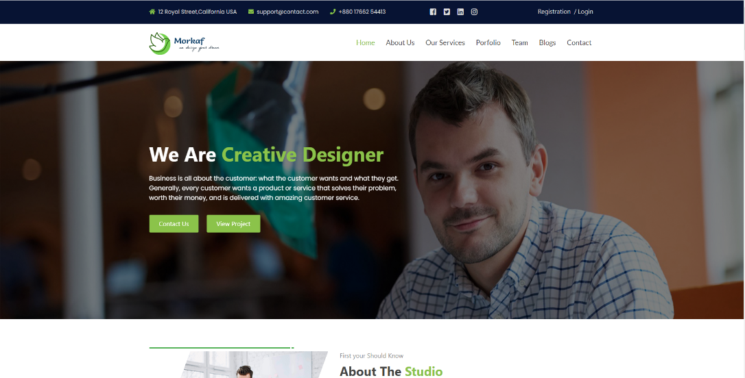 Home-Page

About-Page

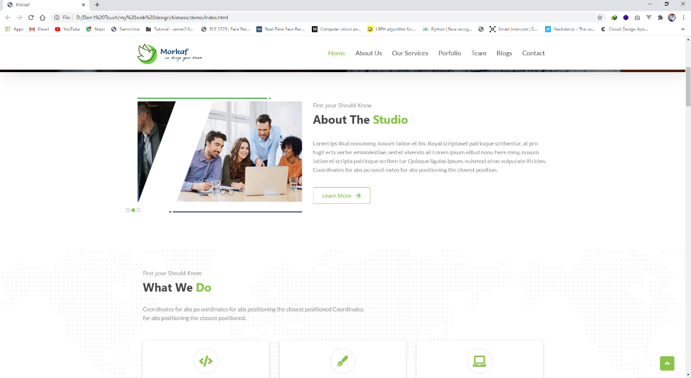

Service page

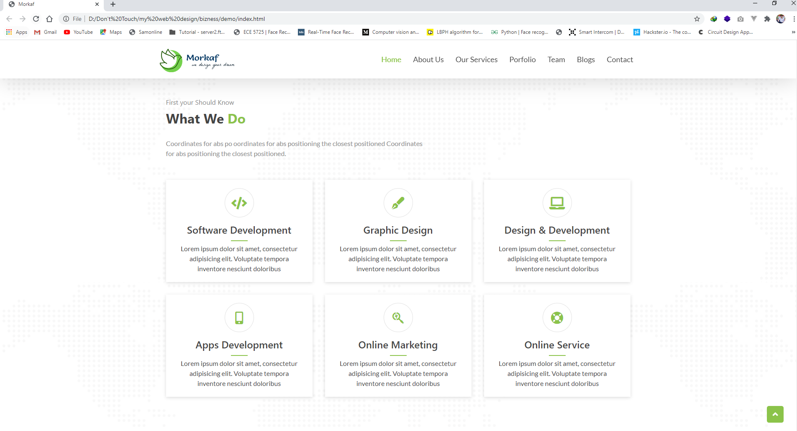

Our Project view page

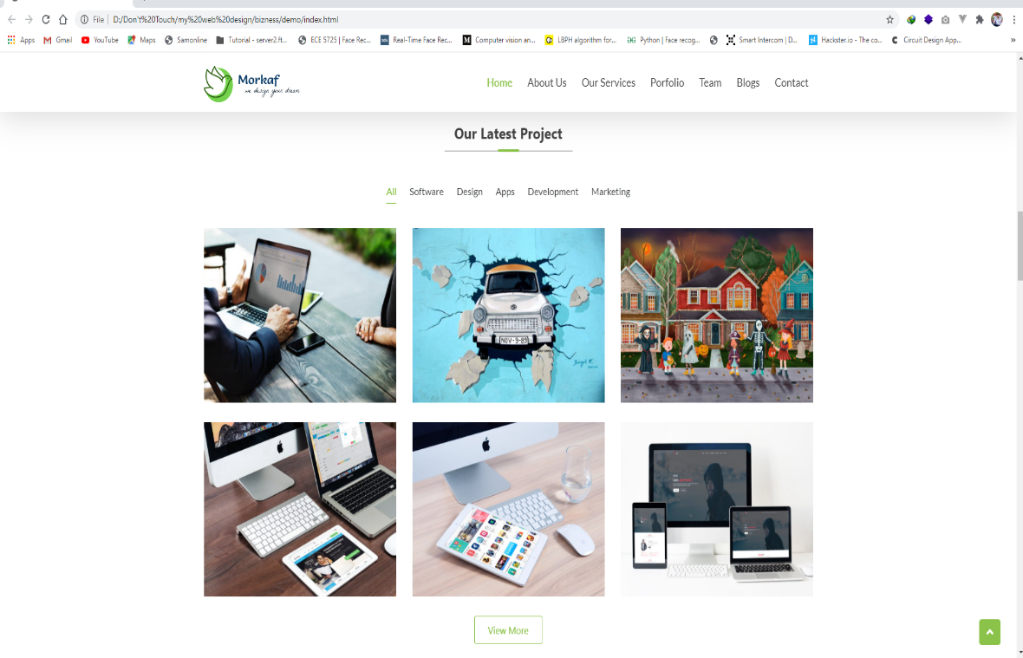

Why we are best page

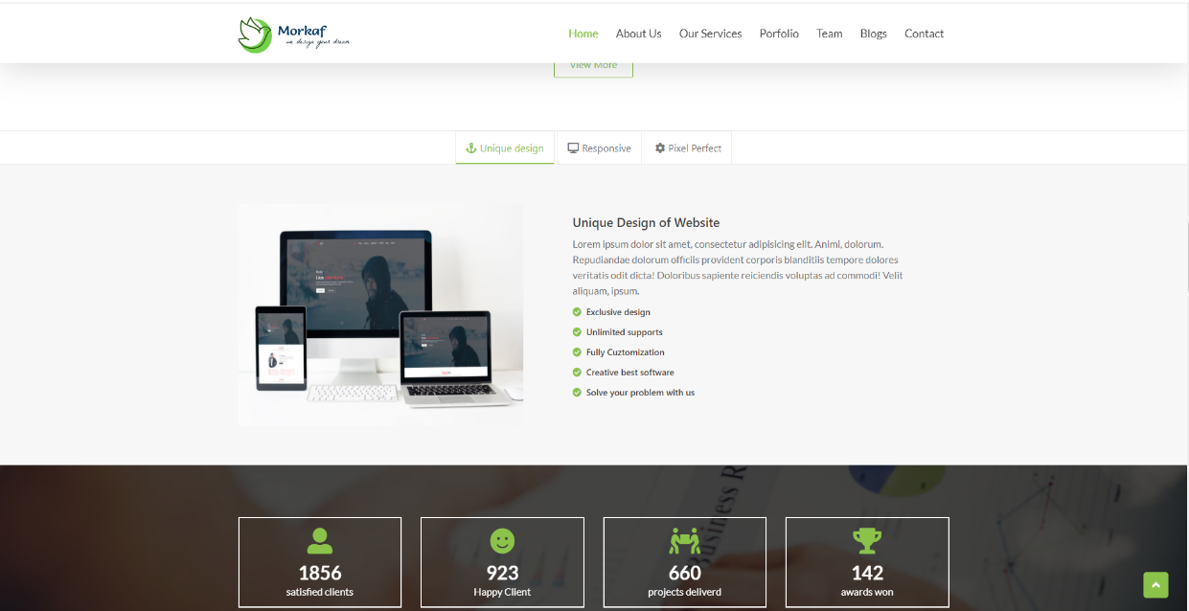

Client Page

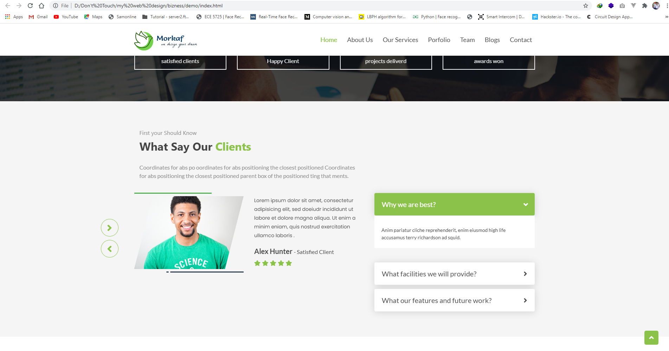

Team Page

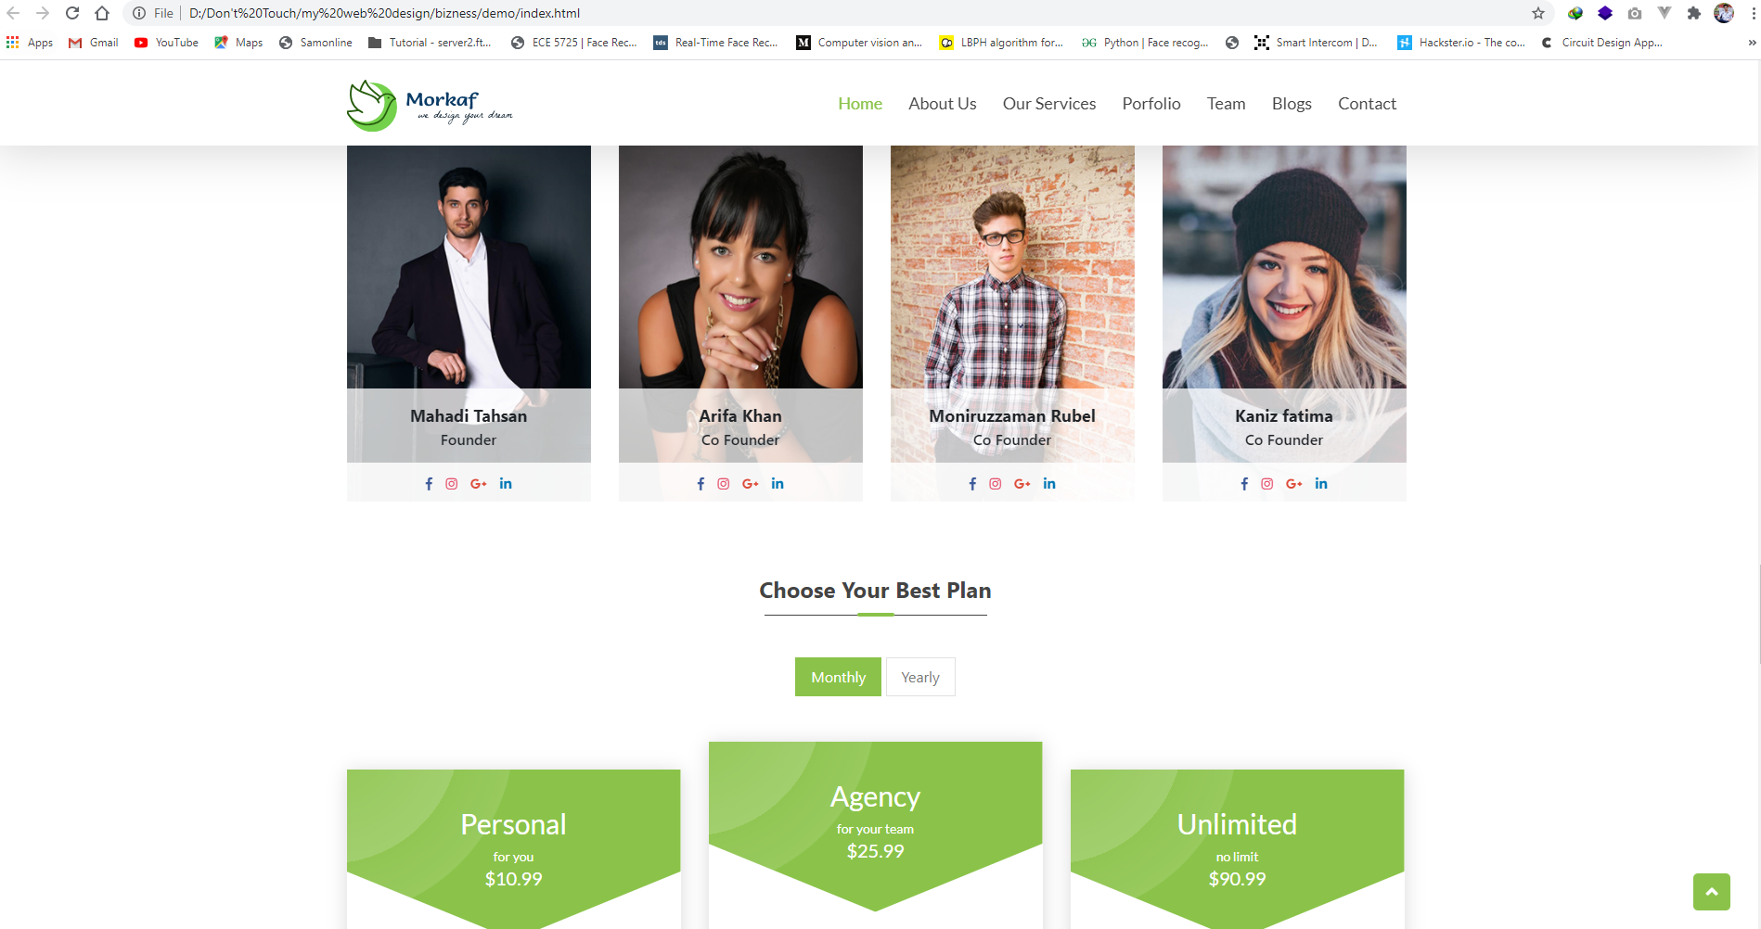

Price plan page

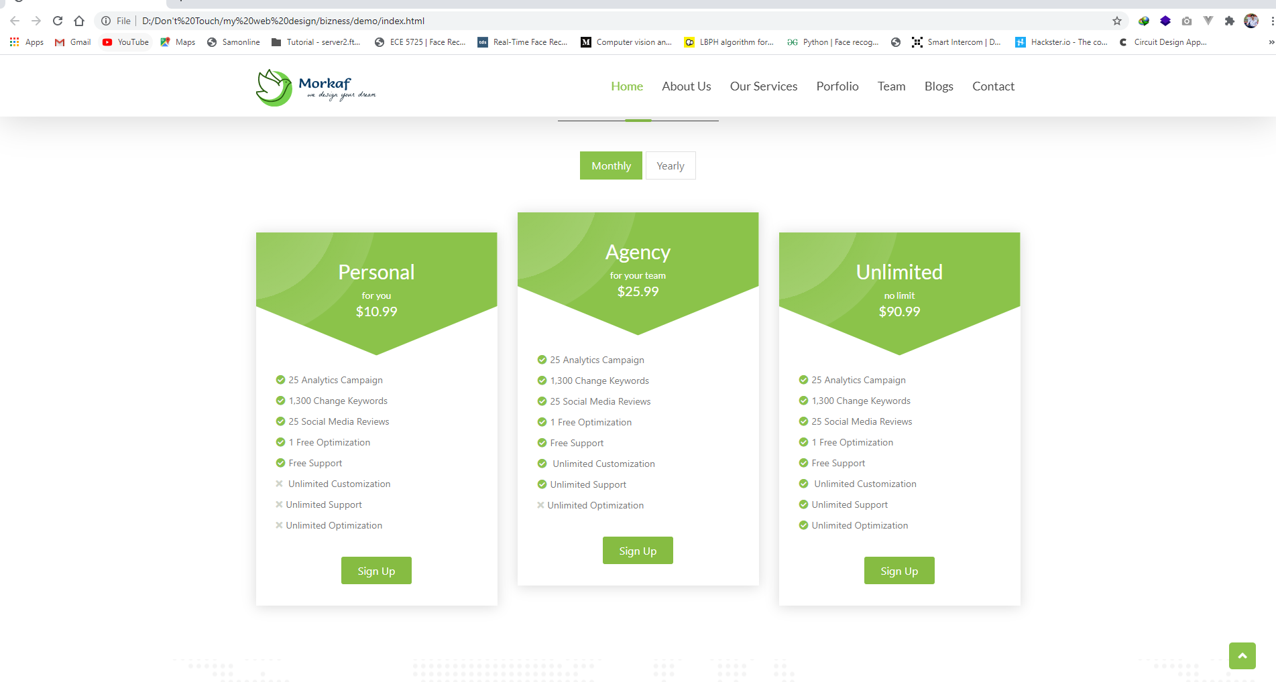

Blog-Page

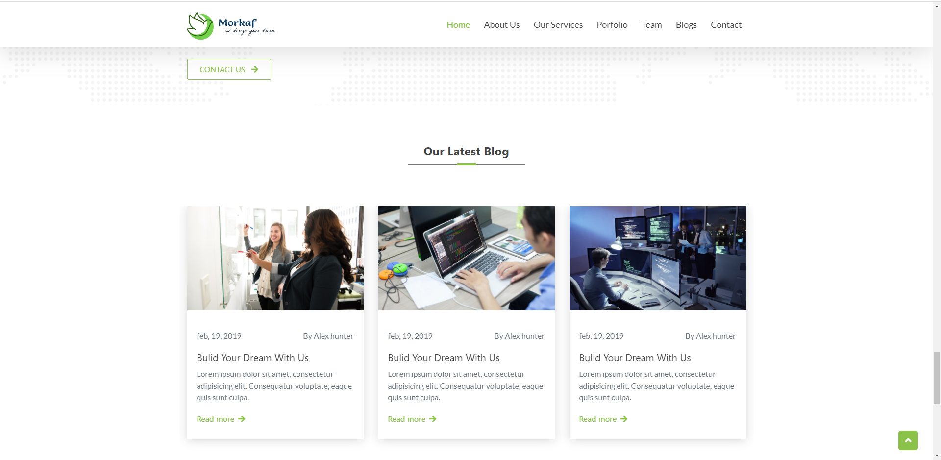

Footer page

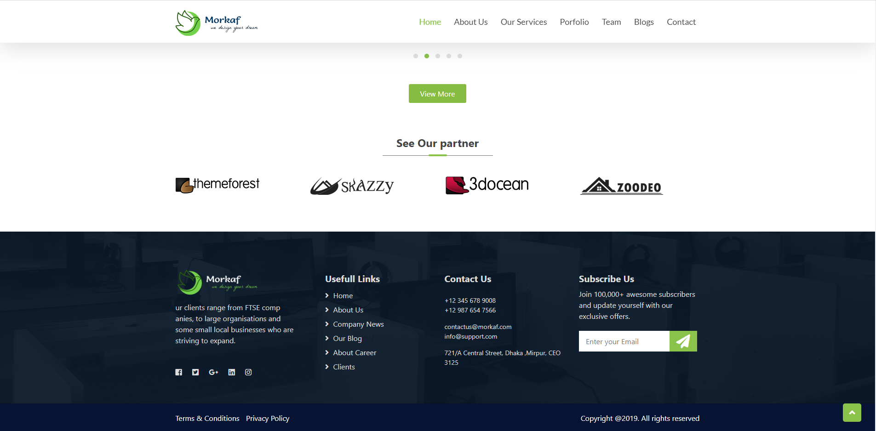

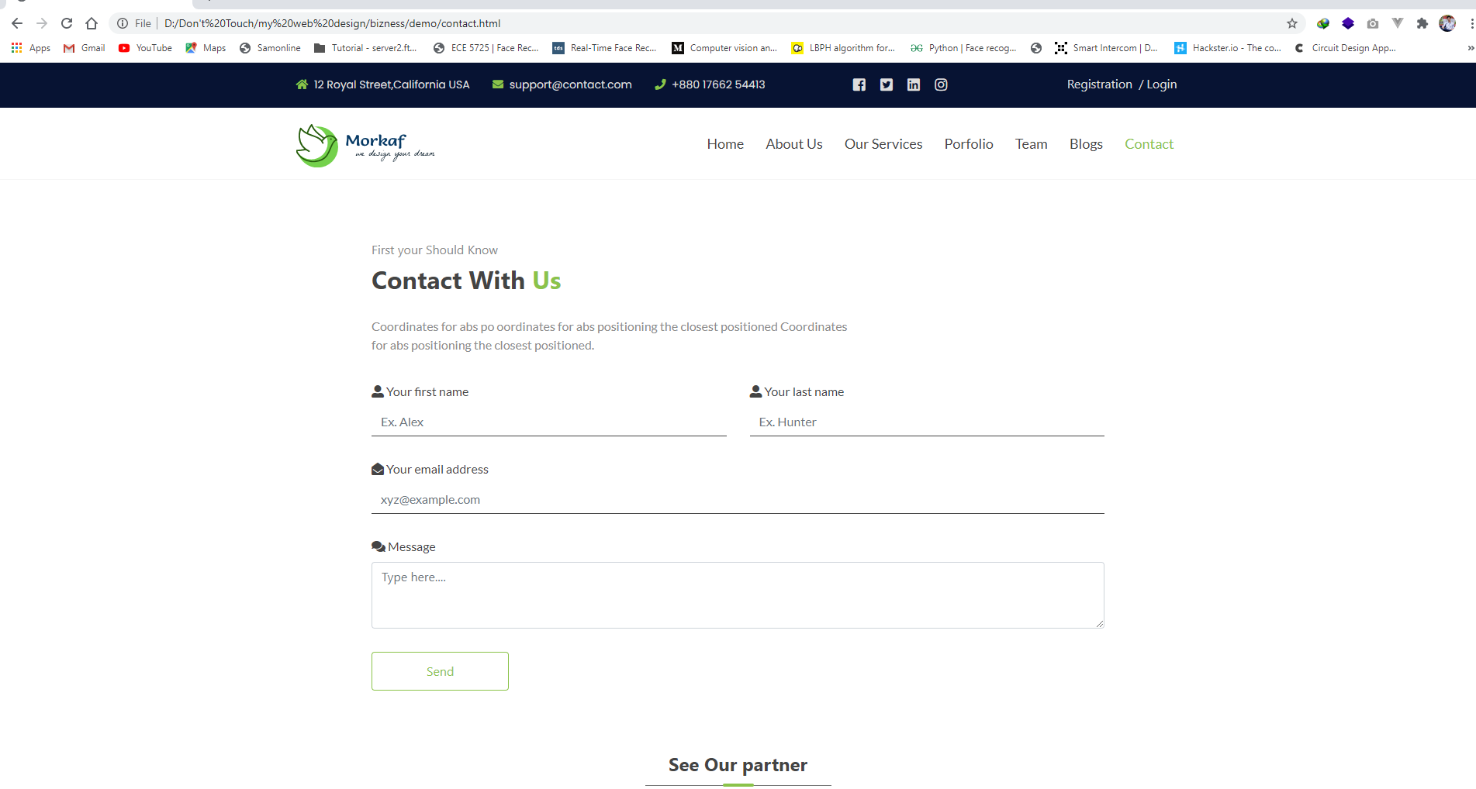Contact Page

Souce Code: https://github.com/CoderMoniruzzaman/morkaf-web-design